FOR FURTHER INFORMATION CONTACT: DATE: Dec. 11, 2019

Chad Schearer (406) 799-7984 FOR RELEASE: On Dec. 11, 2019

E-Mail: chad@bpiguns.com

Tony Smotherman (770) 449-4687 Photo: Attached
E-Mail: tony@bpiguns.com

Bergara Rifles is excited to announce their B-14R .22 LR Rifle is now shipping
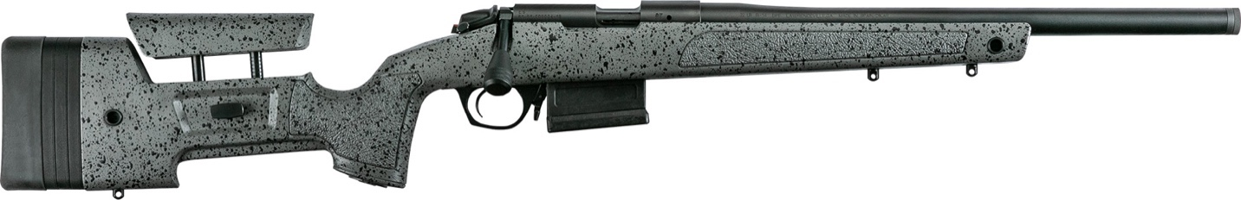

Lawrenceville, Georgia – Bergara Rifles is pleased to announce that their Bergara B-14R .22 LR Rifle is now shipping.
Whether it’s for use in the surging popularity of .22 competitions or as a .22 rifle trainer, the new B-14R, with Bergara’s legendary reputation for accuracy, is going to be a game changer in the rimfire world.

This new rifle is built on a full scale REM700 footprint, including a 90 lift and longer bolt throw. These features allow shooters to have the same size and feel to their centerfire rifle and accommodates the use of other REM700 compatible stocks, bases, and triggers.
Because the B-14R is based on a full-size receiver design, it also provides a perfect platform to allow any shooter the ability to customize their rifle with all kinds of compatible accessories already in the market. The B-14R features a 10-round magazine modified single stack .22LR design that is built to similar dimensions as a standard short action AICS mag.
The B-14R will be available in retailers across the country beginning this week. For more information or help in locating a Bergara stocking dealer, please go to www.Bergarausa.com.

____________

###

BPI Outdoors is headquartered in Lawrenceville, Georgia, with affiliated manufacturing facilities in Northern Spain. The company specializes in shooting and hunting related products. BPI Outdoors is the world leader in muzzleloading rifles and accessories with the CVA, Powerbelt, and Durasight brands. BPI is also an OEM supplier to several of the world’s top firearms manufacturers with its Bergara brand of premium barrels and actions, that also markets both custom and production rifles under the BERGARA name. In the realm of general shooting and hunting accessories, BPI’s Quake brand is a market leader in gun slings, optic covers, and other unique outdoor accessories.

