FOR FURTHER INFORMATION CONTACT: DATE: Oct 18, 2019

Chad Schearer (406) 799-7984 FOR RELEASE: Oct 22, 2019

E-Mail: chad@bpiguns.com

Tony Smotherman (770) 449-4687 Photo: Attached
E-Mail: tony@bpiguns.com

Bergara announces the addition of the 6.5 PRC and
.300 PRC calibers to the B14 series at the NASGW Expo in Orlando Oct. 22-25, 2019
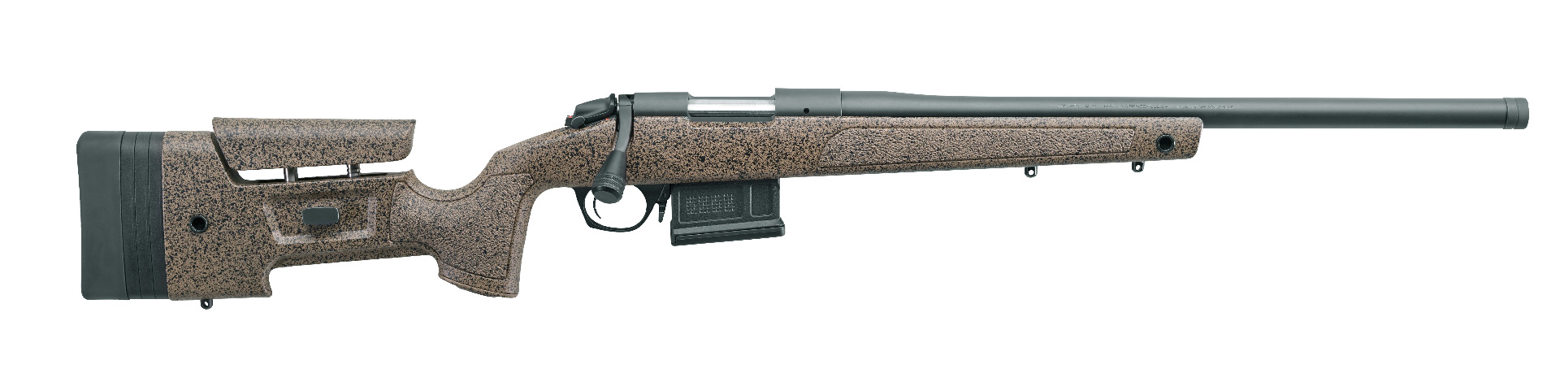
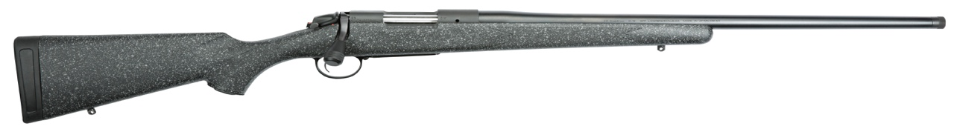
Lawrenceville, GA – Bergara will introduce two new exciting calibers in the popular B-14 HMR and Ridge models at the NASGW Expo in Orlando, FL. on Oct. 22-25, 2019. These new configurations will be available for immediate shipment to the market. Bergara feels that these new high-performance calibers provide their customers with what they have been asking for. “We have been very pleased with the demand for the new PRC calibers in our Premier series, but equally as import, the actual performance they are delivering.” Stated, Nate Treadaway, CEO of BPI Outdoors, which is the parent company of Bergara. He continues, “Based on these two facts, it is only natural that we extend the chamberings to our two most popular B14 models.” The B-14 Rifle was designed with the purpose of offering customers a feature-rich hunting / match rifles ideal for longer range big game hunting, varmint hunting, and also a versatile target shooting rifle. The Bergara B-14’s are built in Bergara, Spain, at the same factory where all of our Bergara barrel blanks are manufactured.

Like all Bergara B-14 Series rifles, they are affordably priced and packed with features. rifle a unique cosmetic appeal. All B-14 rifles are guaranteed capable of producing sub-1.0 MOA groups or less at 100 yards using factory match grade ammunition.
____________
###

BPI Outdoors is headquartered in Lawrenceville, Georgia, with affiliated manufacturing facilities in Northern Spain and Idaho. The company specializes in hunting and shooting related products, and is the world leader in muzzleloading rifles and accessories with the CVA, POWERBELT and DURASIGHT brands. BPI is also an OEM supplier to several of the world’s top firearms manufacturers with its BERGARA brand of premium barrels and actions, and also markets custom and production rifles under the BERGARA name. In the realm of general hunting and shooting accessories, BPI’s QUAKE brand is a market leader in gun slings, optic covers, and other unique outdoor accessories.

